***TARA STORE DATA ANALYSIS***

An Excel Project on Store Data and Visualization using Excel Dashboard.

**Vishal L S**

**28/03/2024**

**Objective**

Tara Store wants to create an Annual Sales Report for 2022. So that, they can Understand their customers and grow more sales in 2023.



**TARA STORES**



**Introduction**

The purpose of this report is to present the findings from the analysis of store data. The dataset comprises various metrics related to sales, inventory, customer demographics, and other relevant factors. The objective of the analysis is to extract insights that can inform decision-making processes aimed at improving store performance, optimizing inventory management, and enhancing customer satisfaction.

**Data Collection**

The dataset was collected from the store's database, encompassing sales records, inventory data, and customer information. The dataset covers a specified time, typically ranging from several months to a year, depending on the availability of data.

**Data Cleaning**

Prior to analysis, the dataset underwent cleaning processes to address missing values, outliers, and inconsistencies. Excel's built-in functions and tools such as sorting, filtering, and conditional formatting were utilized for data cleaning.

**Data Processing**

In this process we created a new column called “Age Group” and we categorized the age group into three sections using the ‘IF’ Function and separated them based on Gender. This will make analyzing the data much easier. Then we created a new column Month and then using the formula ‘TEXT’ we extracted the month so that we can calculate using each month data.

**Data Analysis & Visualization**

Data Analysis was performed to understand the distribution of data, identify patterns, and explore relationships between variables. Excel's charts, pivot tables, and descriptive statistics functions were used for visualization and analysis.

* Comparing the Sales and Orders using Single Chart

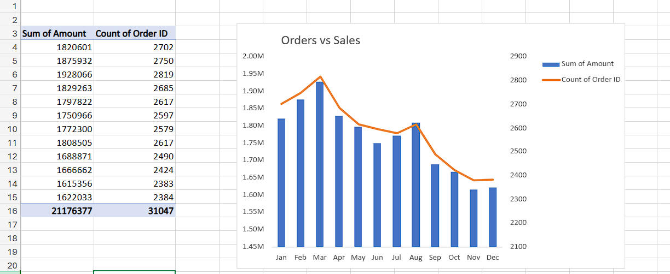

* Comparing who purchased more between Men & Women

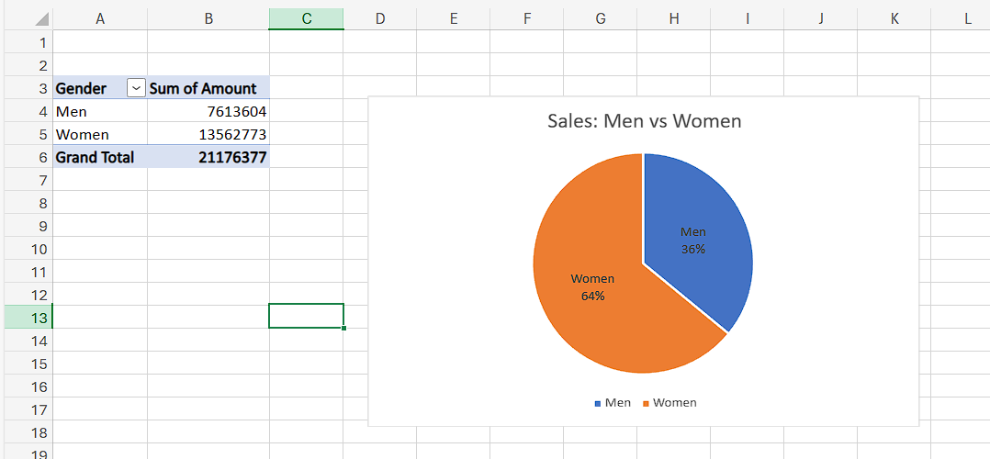

* Different Order Status

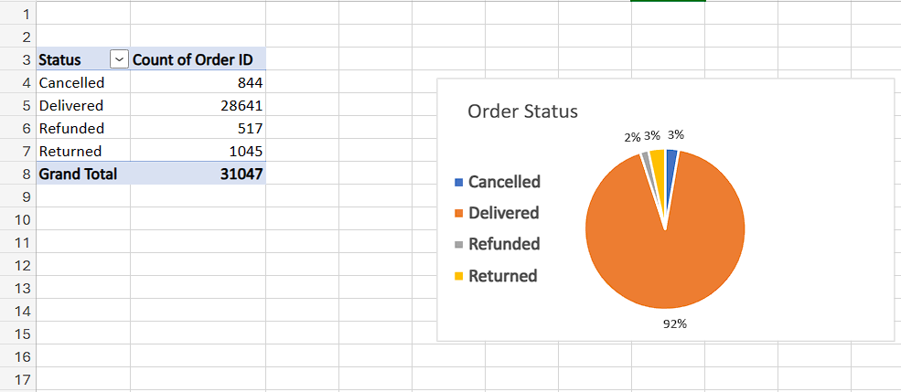

* Top 5 States Contributing to the Sales

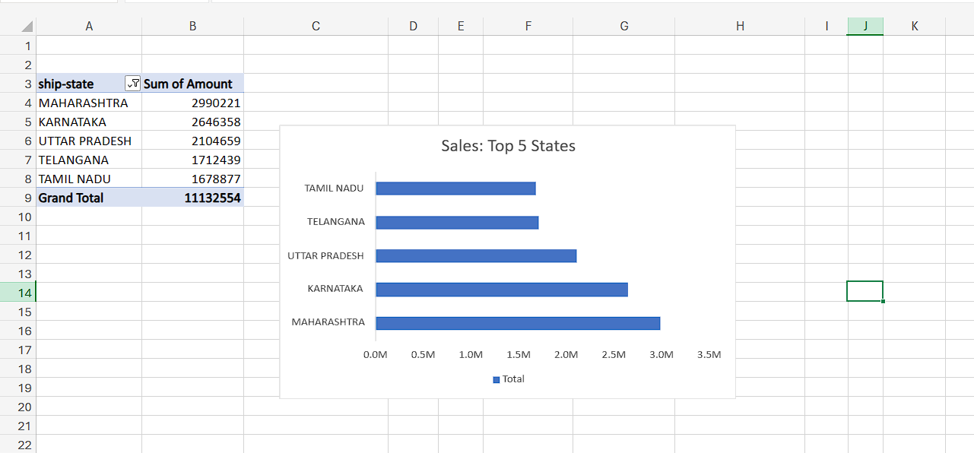

* Relation between Age & Gender Based on number of Orders

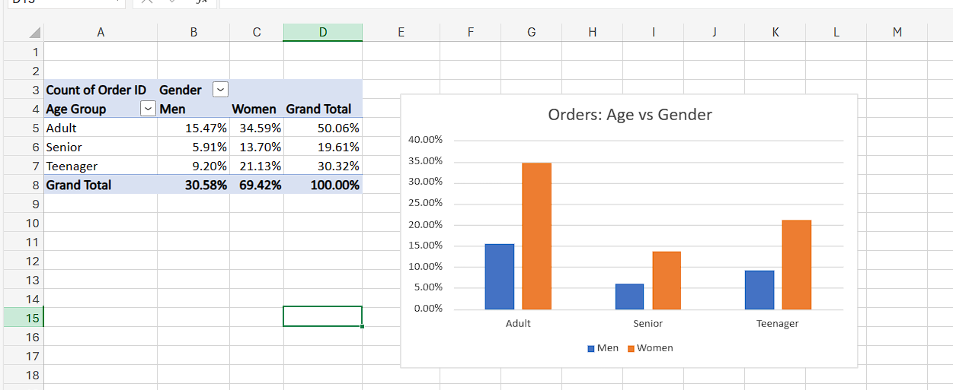

* Channel Contributing to Maximum Sales

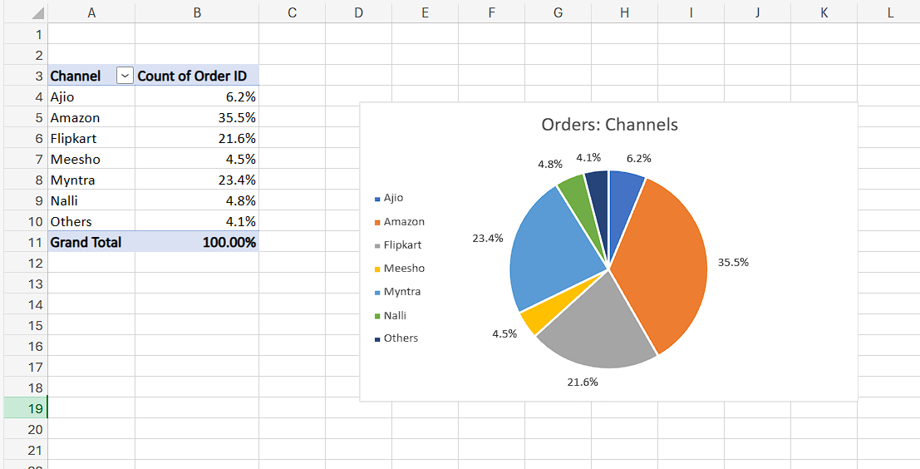

**Annual Report Dashboard**

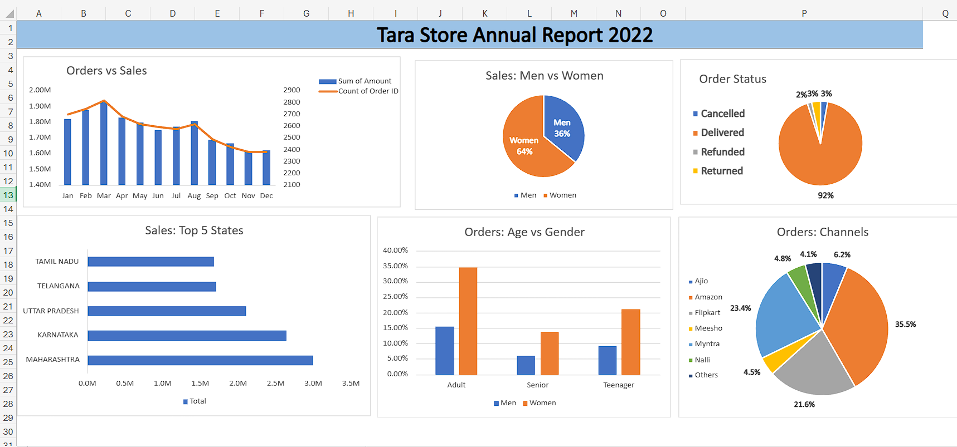

**Key Findings**

* Women are more likely to buy compared to men (~65%)
* Maharashtra, Karnataka and Utter Pradesh are top 3 States
* Adult age group is Max Contributing (~50%)
* Amazon, Flipkart and Myntra channels are Maximum Contributors.

**Conclusion**

The analysis of store data using Excel has provided valuable insights into sales trends, customer behavior, and operational performance. By leveraging these insights, the store can make informed decisions to drive growth and improve competitiveness in the market.

To Improve the Sales, we can target Women customers of age group (30-49) years living in Maharashtra, Karnataka and Utter Pradesh by providing Ads/Coupons/Offers available on Amazon, Flipkart and Myntra.

**Recommendations**

* Implement targeted marketing campaigns aligned with seasonal sales trends and customer segments.
* Utilize inventory optimization techniques to minimize stockouts and excess inventory, thereby improving operational efficiency and reducing costs.
* Personalize customer interactions and offerings based on segmentation analysis to enhance customer satisfaction and loyalty.
* Continuously monitor and analyze customer feedback to identify areas for improvement in service quality and overall shopping experience.